Name: Mohamed Nabil Refaat ElGabar Dept: SWE

Probability HW2

A(Q1):

The number of ways to choose 4 students out of 12 is 12 choose 4 which is equal to (12!)/(4!(12-4)!) = 495.

Since there are 3 tests, we need to multiply this result by 3! (3 factorial) which is equal to 6 because there are 6 ways to assign the tests to the groups of students.

Therefore, the total number of ways that 12 students can take 3 different tests if 4 students are to take each test is 495 \* 6 = 2970.

A(Q2):

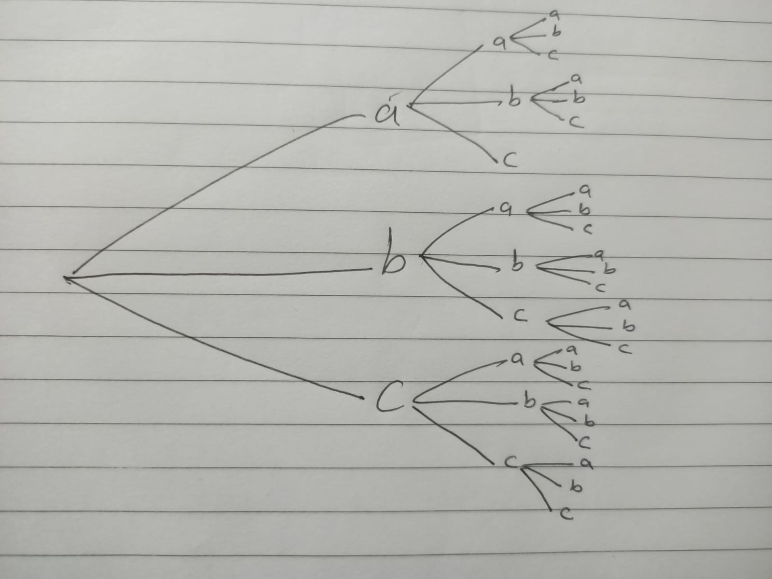

A(Q3):

i)

P(A) = (4/12) \* (3/11) = 1/11

P(B) = (8/12) \* (7/11) = 14/33

ii)

P(at least one item is defective) = 1 - P(both items are non-defective)

We already calculated P(both items are non-defective) in part i):

P(both items are non-defective) = (8/12) \* (7/11) = 14/33

Therefore, P(at least one item is defective) = 1 - (14/33) = 19/33

A(Q4):

i)

P(none defective) = (10/15) \* (9/14) \* (8/13) = 24/65

ii)

P(first item defective) = (5/15) \* (10/14) \* (9/13) = 3/26 P(second item defective) = (10/15) \* (5/14) \* (9/13) = 3/26 P(third item defective) = (10/15) \* (9/14) \* (5/13) = 3/26

The probability of exactly one item being defective is the sum of these probabilities:

P(exactly one defective) = P(first item defective) + P(second item defective) + P(third item defective) = 3/26 + 3/26 + 3/26 = 9/26

iii)

P(at least one defective) = 1 - P(none defective)

We already calculated P(none defective) in part i):

P(none defective) = 24/65

Therefore,

P(at least one defective) = 1 - (24/65) = 41/65

A(Q5):

P(boy or from Mansoura) = P(boy) + P(from Mansoura) - P(boy and from Mansoura)

P(boy) = 10/30 = 1/3 P(from Mansoura) = (5+10)/30 = 1/2 P(boy and from Mansoura) = 5/30

Therefore,

P(boy or from Mansoura) = (1/3) + (1/2) - (5/30) = 11/30

So the probability that a person chosen randomly is a boy or from Mansoura university is 11/30.

A(Q6):

i) To find P(Ac), we can use the complement rule:

P(Ac) = 1 - P(A) = 1 - 3/8 = 5/8

ii) To find P(Bc), we can use the complement rule:

P(Bc) = 1 - P(B) = 1 - 1/2 = 1/2

iii) To find P(Ac intersection Bc), we can use the formula:

P(Ac intersection Bc) = P((A union B)c)

We know that:

P(A intersection B) = 1/2

Therefore,

P((A union B)c) = 1 - P(A union B)

We can use the formula for the probability of the union of two events:

P(A union B) = P(A) + P(B) - P(A intersection B)

We know that:

P(A) = 3/8 P(B) = 1/2 P(A intersection B) = 1/2

Therefore,

P(A union B) = (3/8) + (1/2) - (1/2) = 7/8

So,

P((A union B)c) = 1 - (7/8) = 1/8

Therefore,

P(Ac intersection Bc) = P((A union B)c) = 1/8

iv) To find P(Ac union Bc), we can use the formula:

P(Ac union Bc) = P((Ac intersection Bc)c)

We already calculated P(Ac intersection Bc):

P(Ac intersection Bc) = 1/8

Therefore,

P((Ac intersection Bc)c) = 1 - (1/8) = 7/8

So,

P(Ac union Bc) = P((Ac intersection Bc)c) = 7/8

v) To find P(A intersection Bc), we can use the formula:

P(A intersection Bc) = P(Bc|A)\*P(A)

We know that:

P(Bc|A) = P(A intersection Bc)/P(A) = (1/8)/(3/8) = 1/3 P(A) = 3/8

Therefore,

P(A intersection Bc) = (1/3)\*(3/8) = 1/8

vi) To find P(B intersection Ac), we can use the formula:

P(B intersection Ac) = P(B|Ac)\*P(Ac)

We know that:

P(B|Ac) = P(Ac intersection B)/P(Ac) = (1/2)/(5/8) = 4/5 P(Ac) = 5/8

Therefore,

P(B intersection Ac) = (4/5)\*(5/8) = 1/2

A(Q7):

P(at least one 7) = 1 - P(no 7s)

To find P(no 7s), we need to find the probability of not rolling a 7 on any of the three tries. The probability of not rolling a 7 on one try is:

P(no 7) = 36/36 - 6/36 = 30/36

The probability of not rolling a 7 on all three tries is:

P(no 7s) = (30/36)^3 = 0.5787

Therefore,

P(at least one 7) = 1 - P(no 7s) = 1 - 0.5787 = 0.4213

So the probability that at least one of the three tries, you roll a 7 is approximately 0.4213.

A(Q8):

The sum of all probabilities must be equal to 1. Therefore,

Σ P(x) = 1

So we can set these two equations equal to each other:

k^2 - 8 = 1

Solving for k, we get:

k^2 = 9

k = ±3

Since k is a positive value (since it represents a probability), we take the positive square root:

k = 3

Therefore, the value of k is 3.

A(Q9):

A’ intersection B’ = (A union B)’

We know that A and B are mutually exclusive, so:

A intersection B = 0

Therefore,

A union B = A + B

So we can write:

P(A’ intersection B’) = P((A union B)') = 1 - P(A union B)

We know that:

P(A) = 0.35 P(B) = 0.45

Since A and B are mutually exclusive, we can add their probabilities to get:

P(A union B) = P(A) + P(B) = 0.35 + 0.45 = 0.8

Therefore,

P(A’ intersection B’) = 1 - P(A union B) = 1 - 0.8 = 0.2

So the probability of A’ intersection B’ is 0.2.